IT13: ADBMS
Chapter 2:SQL
Practice Assignment Solution Template

Write a query and paste a screenshot of your output below the question.
- Create a database named CompanyDB.
Solution: -
CREATE DATABASE CompanyDB;
SHOW DATABASES;
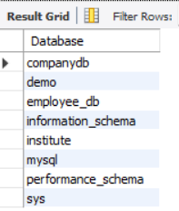
- Create a table Employees with the following columns:
Employees (EmpID (Integer, Primary Key), EmpName, Salary, JoinDate )
Solution: -
CREATE TABLE Employees (
EmpID INT PRIMARY KEY,
EmpName VARCHAR(50),
Salary INT,
JoinDate DATE
);
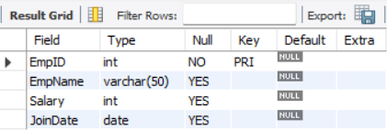

- Create a table Departments with:
Departments (DeptID (Integer, Primary Key), DeptName)
Solution: -
CREATE TABLE Departments (
DeptID INT PRIMARY KEY,
DeptName VARCHAR(100)
);
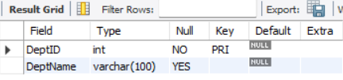
- Add a column Email (VARCHAR(100)) to the Employees table.
Solution: -
ALTER TABLE Employees
ADD Email VARCHAR(100);
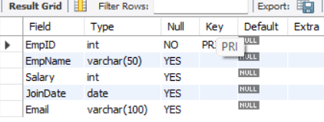

- Add a column dept_location to the Departments table.
Solution: -
ALTER TABLE Departments
ADD dept_location VARCHAR(100);
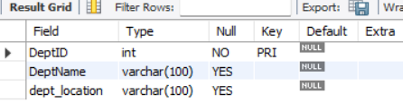
- Add a NOT NULL Constraint to the Phone column.
Solution: -
ALTER TABLE Employees
ADD Phone VARCHAR(15) ;

ALTER TABLE Employees
MODIFY Phone VARCHAR(15) NOT NULL;
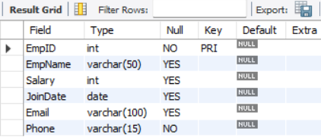

- Change the size of the EmpName column from VARCHAR (50) to VARCHAR (100).
Solution: -
ALTER TABLE Employees
MODIFY EmpName VARCHAR(100);
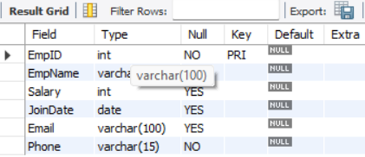

- Drop the primary key Constraint from Departments.
Solution: -
ALTER TABLE Departments
DROP PRIMARY KEY;
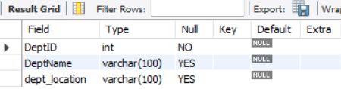
- Create a foreign key constraint between two tables.
Solution: -
ALTER TABLE Employees
ADD DeptID INT;

ALTER TABLE Employees
ADD CONSTRAINT fk_employee_department
FOREIGN KEY (DeptID)
REFERENCES Departments(DeptID);
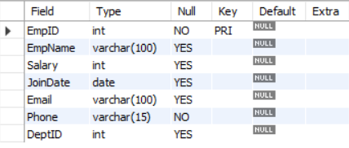
- Rename the column EmpName to EmployeeName.
Solution: -
ALTER TABLE Employees
RENAME COLUMN EmpName TO EmployeeName;
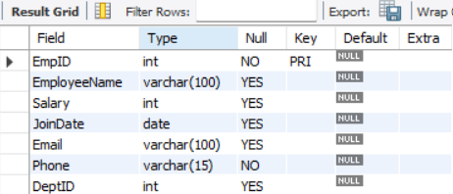

- Apply a CHECK constraint on the Age and Salary columns.
Solution: -
ALTER TABLE Employees
ADD Age INT;

ALTER TABLE Employees
ADD CONSTRAINT chk_employee_age
CHECK (Age >= 18);

ALTER TABLE Employees
ADD CONSTRAINT chk_employee_salary
CHECK (Salary > 0);
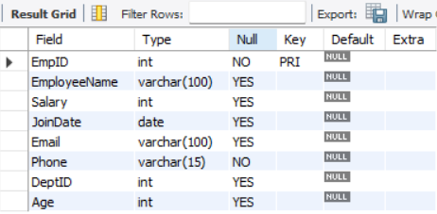
- Remove the Phone column from the Employees table.
Solution: -
ALTER TABLE Employees
DROP COLUMN Phone;
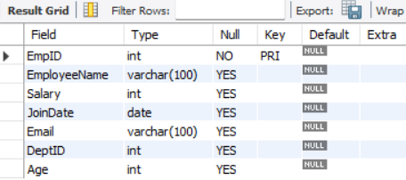

- Rename the table Employees to EmployeeDetails.
Solution: -
RENAME TABLE Employees TO EmployeeDetails;
SHOW TABLES;
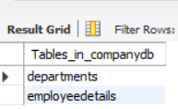
- Drop the CHECK constraints.
Solution: -
ALTER TABLE EmployeeDetails
DROP CHECK chk_employee_salary;
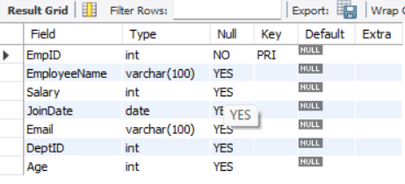
- Delete the Departments table permanently.
Solution: -
DROP TABLE Departments;
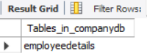
- Drop the database.
Solution: -
DROP DATABASE CompanyDB;

SHOW DATABASES;
